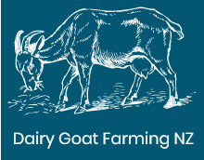

Dairy Goat Parasite Management Plan  
*Cut and Carry Systems*

*Rationale:*

Goats have less ‘built-in’ natural immunity to worms than other species such as cows and sheep as their natural diet and browsing habits see them less exposed to worm larvae.

Barn housing can create ideal breeding conditions for lice, ticks and other biting/sucking parasites if not monitored and managed well.

*Preventative Measures:*

* Cutting the pasture at least 2 cm higher than the base so that most of the worm larvae is left in the paddock
* Feeding down a centre lane or on a conveyor so the goats are not mucking back on the feed they are eating.
* Regular Preventative Pour-Ons
* Clean, well ventilated housing areas that are not over-crowded
* Regular observation of herd for signs of worm burden (rough coated, be losing weight, and have bad diarrhoea)
* Regular observation of herd for signs of external parasites (patchy hair loss, visibly biting and scratching themselves, weight loss, anaemia)
* Where clinical signs are evident, treatment can follow the same procedure as for preventative measures. For extreme or non-responsive cases, veterinary advice will be sought.

*Preventative Pour-On Frequency (Intestinal Worms):*

Bucks: At least once per year, ideally 2-3 weeks prior to mating (or more frequently if grazed outside)

Does: Usually once per year during the dry period (late May)

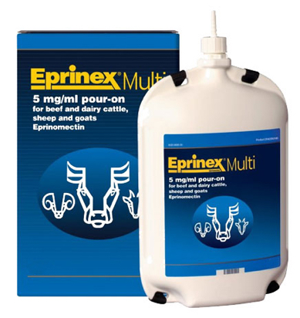NOTE: If there is no indication for needing to do this then it is not done as worm resistance to treatments is a serious issue. Individual animals or small groups may be treated as required throughout the milking season.

*Products Used:*

**Eprinex Multi Pouron** (Registered for goats). For worm and lice control

Dose rate: 2 ml per 10 kg (so 12 – 14 ml for average sized does)

Meat Withholding: 1 day

Milk Withholding: Nil

**Note**: Not Eprinex for cattle – only Eprinex Multi is registered for goats

**Eprisure is a similar product but is not registered for goats so must only be used under guidance from a veterinarian**

**Oral Drench**: We use Matrix only on our bucks and only when grazed outside. **This product is not registered for goats so must be used in consultation with your vet.**

**Lice Treatment**:

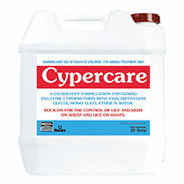**Cypercare** (registered for goats). For biting and sucking lice. Best used during the winter period as this is when they are most likely to have infestations and also likely that the goats will be dry which makes managing the milk withholding times easier. Due to resistance issues, only use if evidence of lice exists, such as dull coats, visible signs of biting or scratching or patches of hair missing.

Meat Withholding: 14 days

Milk Withholding: 35 days

**Note:** Eprinex Multi is also used for the control of biting and sucking lice so if this has been used, you may not need a separate lice treatment such as Cypercare.